**July 2023-June 2024**

**ANNUAL REPORT**

**HANDS OFF FOUNDATION**

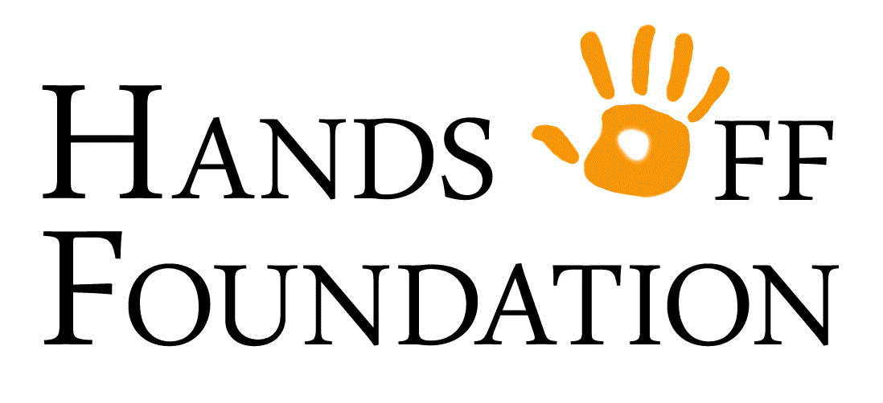

## Our Mission

Our Mission is to aid the healing process for families and survivors of Family Violence and Sexual Assault by providing tangible and meaningful support at times when they need it the most

## Our Vision

To have the Hands Off Foundation recognised as an organisation that through genuine caring and support, provides positive outcomes and futures for families and individuals who have been affected by Family violence and Sexual Assault

## Our Values

At Hands Off Foundation, we value:

​

* Those families and individuals who have been affected by Family Violence and Sexual Assault
* The trust people place in us to provide healing, support and education to those who have been affected by Family Violence and Sexual Assault
* Confidentiality, ethics and caring in everything we do
* Everyone who supports us and contributes to our success in achieving our Mission and Vision
* Our “no-judgement, no questions asked” approach to the people we support

**CONTENTS**

|  |  |
| --- | --- |
| Our mission | Page 2 |
| Our vision | Page 2 |
| Our values | Page 2 |
| **Section 1 – An overview of Hands Off Foundation** |  |
| About us | Page 4 |
| Our people | Page 5-6 |
| **Section 2 – Governance** |  |
| Structure & management | Page 7 |
| Chairperson’s report | Page 8-9 |
| Our Objectives and Activities | Page 10 |
| **Section 3 – Our Finances** |  |
| Treasurer’s report | Page 11-13 |
|  |  |
| **Section 4 – Our other important information** | Page 14 |
| Thankyou | Page 15 |
| Donors / How you can help | Page 16 |
| Contact us | Page 16 |

|  |  |
| --- | --- |
| **SECTION 1** | **AN OVERVIEW OF Hands Off Foundation** |

**ABOUT US**

###### Who does Hands Off work with?

The Foundation works with reputable government bodies such as the Centre Against Sexual Assault (CASA), Sacred heart mission, Salvation Army, Better Health and Each, to ensure funding is available and allocated to appropriate clients and their families who have been victims of sexual assault. Those that are recipients of any support provided by the Hands Off Foundation are directly connected with these organisations and have no subjective or preferential treatment.

###### 

###### How does Hands Off help?

With the funds raised, the Foundation supports these organisations mission by providing their clients and their families with vouchers of their choice to assist in the healing process and compliment the counselling programs provided. What makes Hands Off unique is that it is committed to providing what a client feels would aid them the most in their recovery – not what has been selected for them. Unlike VOCAT (Victims of Crime Tribunal) who only subsidise for recognised Western methods such as Psychology and Medical Practitioners, the foundation provides vouchers for all types of Western and Eastern modalities as well as family entertainment services, fuel and grocery vouchers and variety packs (such as Westfield Vouchers to use at a store of their choice).

In 2019/20 Hands Off was also able to provide care packs for children which included a teddy, balloon, bubbles, colouring books, pencils, sharpener and a pencil case. During this time adults also had access to care packages containing journals, crystals, a pen, therapeutic colouring books, pencils and a throw rug. Currently adults have access to therapeutic colouring books. Reports from these organisations representatives are that these care packs and vouchers have been invaluable to the healing of their clients, yet with our limited resources the foundation have yet to be able to supply them with the amount required.

**OUR PEOPLE**

|  |  |  |
| --- | --- | --- |
| **Committee Members** | | |
| **Name** | **Position** | **Dates acted**  **(if not for whole year)** |
| Donna Jordan | President | 23/24 |
| Ian Sadler | Vice president/ | 23/24 |
| Stephanie Waldron | Secretary | 23/24 |
| Hayley Carns | Treasurer | 23/24 |

|  |  |  |
| --- | --- | --- |
| **Committee** | | |
|  | | |
| **Name** | **Position** | **Dates acted** |
| Michelle Waldron | Volunteer Coordinator | 23/24 |
| Lauryn Jordan | Social Media | 23/24 |
| David Jordan | Committee | 23/24 |
| Gln Waldron | Committee | 23/24 |

|  |  |  |
| --- | --- | --- |
| **Volunteers** | | |
| **Name** | **Position** | **Dates acted** |
| Cathy Tridgell | Volunteer | 23/24 |
| Lisa Street | Volunteer | 23/24 |
| Trevor Eddy | Volunteer | 23/24 |
| David Carns | Volunteer | 23/24 |
|  |  |  |

|  |  |  |  |  |
| --- | --- | --- | --- | --- |
| i |  |  |  |  |
| Donna Jordan  President | Kate Jordan  Vice president | Stephanie Waldron  Secretary | Hayley Carns  Treasurer | Michelle Waldron  Committee |
|  |  | [ |  |  |
| Lauryn Jordan  Social media | Glen Waldron  Committee | Tina Waldron  Committee | David Jordan  Committee |  |
|  |  |  |  |  |

|  |  |
| --- | --- |
| **SECTION 2** | **GOVERNANCE** |

**STRUCTURE & MANAGEMENT**

Hands Off Foundation is registered with the Australian Charities and Not-for-profits Commission (ACNC).

**PRESIDENTS REPORT**

PRESIDENTS REPORT AGM 2024

Good morning, everyone,

I’d like to extend a warm welcome to all of you, committee members and volunteers. Thank you for joining me at our Annual General Meeting. Your commitment to our mission of supporting individuals and families affected by family and sexual violence is invaluable.

**[Achievements]**

This year has been one of significant achievements and transformation for our organization. I am proud to report that we have been recognized for our efforts with a prestigious award. This accolade was not just an acknowledgment of our hard work, but also a testament to the impact we’re making in the lives of those we serve. I want to express my deepest gratitude to everyone who contributed to this success—you are the heart and soul of our mission.

**[Three-Month Break and Restructuring]**

As you know, earlier this year, we took a three-month break—a bold but necessary step to reflect, recharge, and refocus our efforts. This pause allowed us to critically assess our strategies, strengthen our team, and refine our approaches to better meet the needs of our community.

One of the major outcomes of this period was our decision to restructure the organization. We recognized that to continue growing and responding effectively to the needs of those we serve, we had to adapt. Our restructuring process, though challenging, has positioned us to operate more efficiently and increase our impact.

**[New Subcommittee]**

I am also excited to announce the formation of a new subcommittee dedicated to the referral and application process. This group will bring fresh perspectives and ideas to the table, ensuring that we continue to evolve and meet the ever-changing needs of those affected by family and sexual violence.

**[Impact]**

Above all, our most significant achievement remains the lives we touch. This year, we have supported [number] individuals and families through our services Behind each number is a story—of resilience, of hope, and of a journey to healing. Whether it’s providing safe shelter, counselling, a care pack or voucher for various needs our work makes a profound difference, and I am continually inspired by the strength of those we serve.

However, it’s also been a year of change within our team. We have had to say goodbye to some valued members who have moved on to new opportunities. Additionally, we have one member currently on maternity leave. We wish her all the best during this special time, with her beautiful baby boy and we look forward to her return. Despite these changes, our team’s spirit and dedication remain strong, and we are committed to filling these gaps with the same passion and resolve that define our work.

**[Looking Forward]**

As we look to the future, I am confident that our restructured team and new initiatives will propel us to even greater heights. We will continue to challenge ourselves to be better, do more, and reach further. Our commitment to our mission is unwavering, and with your ongoing support, we will keep pushing forward.

**[Closing]**

Thank you for your dedication, your hard work, and your belief in our mission. Together, we are not just changing lives—we are changing the world, one step at a time.

Let’s continue this journey with renewed energy, passion, and determination.

"Alone we can do so little; together we can do so much." — Helen Keller

Thank you.

**OUR OBJECTIVES AND ACTIVITIES**

This year we undertook multiple fundraisers. This list includes:

* Trivia Night
* Sausage Sizzles at Bunnings
* Shopping Tour

Ongoing sales of merchandise:

* Bracelets
* Pins
* Key rings
* Bumper stickers
* Pens
* Stubby Holders

|  |  |
| --- | --- |
| **SECTION 3** | **OUR FINANCES** |

**TREASURER’S REPORT**

Income

|  |  |  |  |
| --- | --- | --- | --- |
| **MONTH** | **INCOME** | **EXPENSES** | **NET** |
| JAN | $ 9.99 | $ 1,733.02 | $ (1,723.03) |
| FEB | $ - | $ 1,028.92 | $ (1,028.92) |
| MAR | $ 20.00 | $ 10.00 | $ 10.00 |
| APR | $ 0.03 | $ 286.65 | $ (286.62) |
| MAY | $ 552.49 | $ 6,337.33 | $ (5,784.84) |
| JUN | $ 998.00 | $ 5,151.22 | $ (4,153.22) |
| JUL | $ - | $ 10.00 | $ (10.00) |
| AUG | $ 305.60 | $ 5,275.12 | $ (4,969.52) |
| SEP | $ 2,172.60 | $ 645.87 | $ 1,526.73 |
| OCT | $ 1,018.43 | $ 4,609.24 | $ (3,590.81) |
| NOV | $ 20.00 | $ 2,313.16 | $ (2,293.16) |
| DEC | $ 30,537.61 | $ 3,510.84 | $ 27,026.77 |
| **TOTAL** | **$ 35,634.75** | **$ 30,911.37** | **$ 4,723.38** |

|  |  |
| --- | --- |
| **TYPE** | **TOTAL** |
| Fundraising | $ 2,114.54 |
| Donations | $ 10,120.00 |
| Sausage Sizzles | $ 2,197.60 |
| Merchandise | $ 20.00 |
| Misc | $ 1,182.61 |
| Grants | $ 20,000.00 |
|  | $ - |
|  | $ - |
|  | $ - |
|  | $ - |
| **Total Income YTD** | **$ 35,634.75** |

Expenses

|  |  |  |  |  |  |
| --- | --- | --- | --- | --- | --- |
|  | |  | |  | |
| **Expense** | | **Total** | |
| Vouchers | | $ 17,131.86 | |
| Care Packs | | $ 4,504.00 | |
| Advertising | | $ - | |
| Printing/Stationary | | $ - | |
| Bank Fees | | $ 120.00 | |
| Sundries | | $ 2,423.61 | |
| Website | | $ 153.44 | |
| Misc | | $ 1,863.91 | |
| Sausage Sizzle | | $ 404.16 | |
| Fruit | | $ - | |
| Fundraising | | $ 4,118.39 | |
|  | | $ - | |
| **Total Expenses YTD** | | **$ 30,719.37** | |

|  |  |
| --- | --- |
| **SECTION 4** | **OUR OTHER IMPORTANT INFORMATION** |

**ACKNOWLEDGMENTS & THANK YOU**

This is just a couple of examples of the thankyou’s we receive from the survivors.

*I just wish to share a client feedback.*

*Michelle, 60YO female client that the foundation assisted not long ago with the Jaynee Sanders book would like to extend her gratitude to the foundation. Michelle even became teary and this was unusual for her.*

*Michelle had taken full time care of her 2YO granddaughter the last two sessions we have been exploring and discussing body safety, consent, etc. and having the books just added another layer of resource and increased confidence in having navigating these conversations *

*Thank you.*

***Charmaine Morrison (she/her)***

***Social Worker | Counsellor/Advocate***

*SECASSA*

*We have recently begun working with you to provide support to our clients, and I just dropped off some of the first lot of Care packs that were ordered by my colleague Kerry, and I wanted to provide the feedback that the kids LOVED them and were thrilled with all the different bits that were in there. So, thank you*

|  |  |  |  |
| --- | --- | --- | --- |
| **Elizabeth D** | |  | | --- | | | | | **Specialist Family Violence Children's Practitioner** |
| **Vincent Care** |  |  |

*Just wanted to share my client’s appreciation of your generosity – she said so many other things to express her gratitude*

|  |
| --- |
| **Yon Jeong** |
|  |
| MHICC Care Coordinator |
| **Better Health Network (BHN)** |

**Donors**

We had many donations from people and businesses including the donation of goods for raffles and care packs.

**Volunteers:**

* Cathy Tridgell
* Lisa Street
* Trevor Eddy
* David Carns

**HOW YOU CAN HELP**

**To help us in any way please go to our website and follow the links, email us or contact us by phone. Ways which you can help include:**

* **Become a member**
* **Volunteer your time**
* **Make a donation**

Go to our website

* **Support an event or fundraising activity**
* **Become a corporate partner**

**CONTACT US**

283 Karoo rd Rowville Vic 3178

0400679888

[www.handsofffoundation.com.au](http://www.handsofffoundation.com.au)

[handsofffoundation@gmail.com](mailto:handsofffoundation@gmail.com)

Facebook and Instagram